1.Provider file for the Resource.
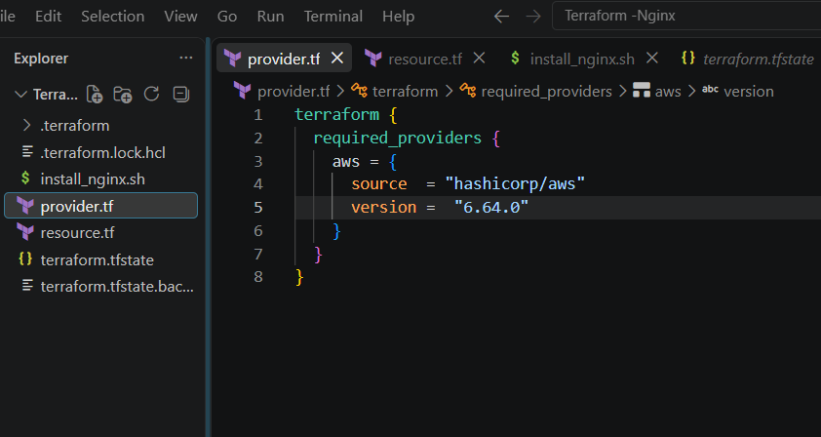
2.Resource block for the Aws Ec2 instance creation.

a.Provider Region block (Us-east and Us-west)
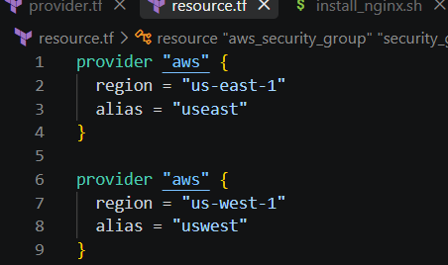
b.Aws instances block for the Instances with user data for Nginx installation and their security groups..
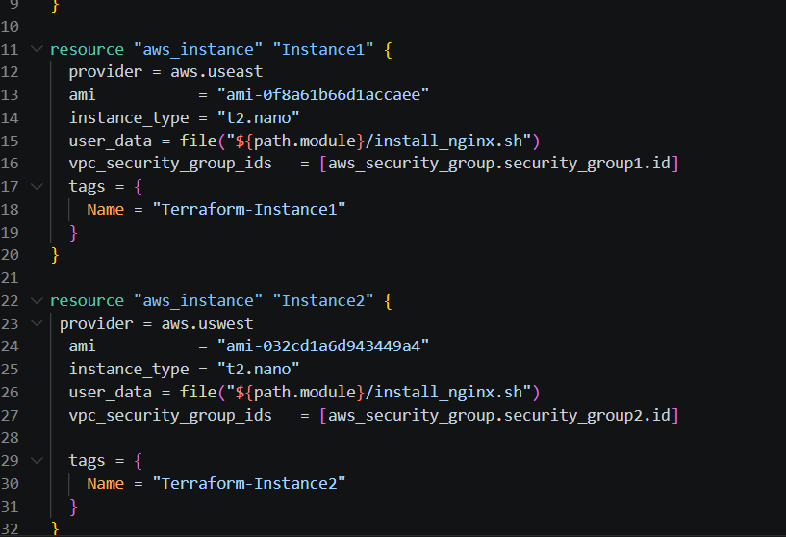
c.Security groups created for the Instances in respective regions with ingress (ssh and Http) and egress (0)
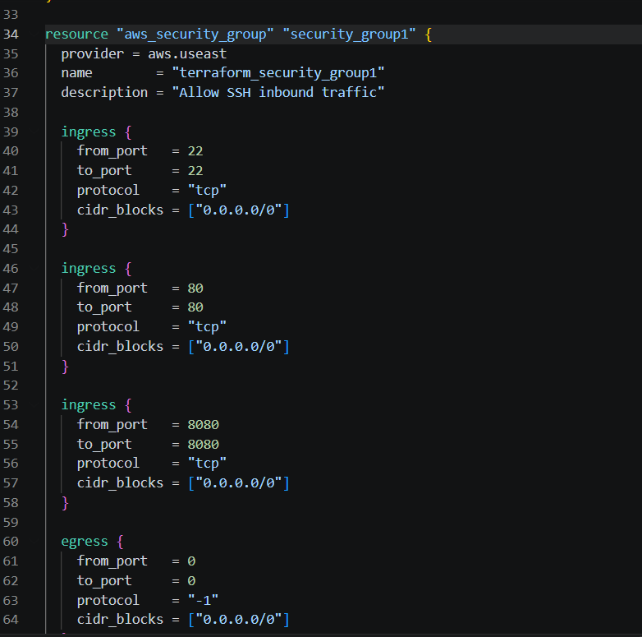
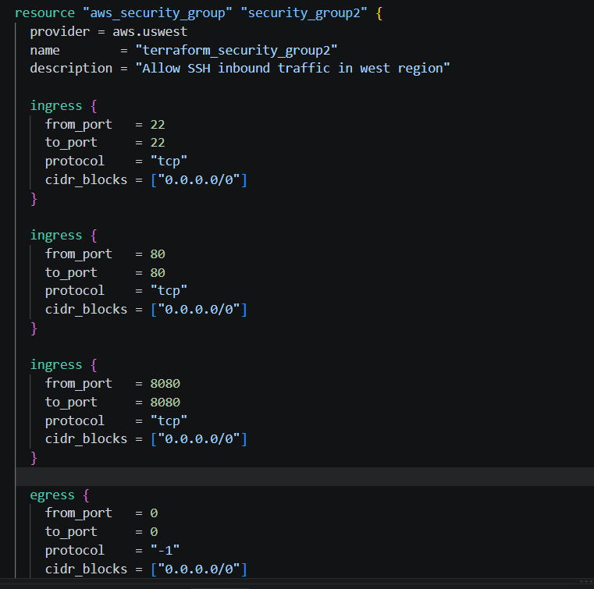
3.User Data script for Nginx installation.
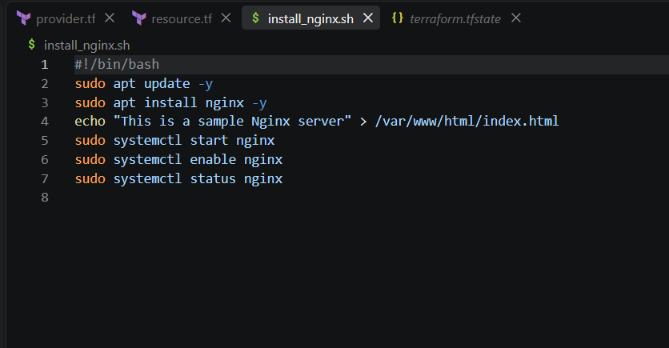
4.Resources created through Terraform.
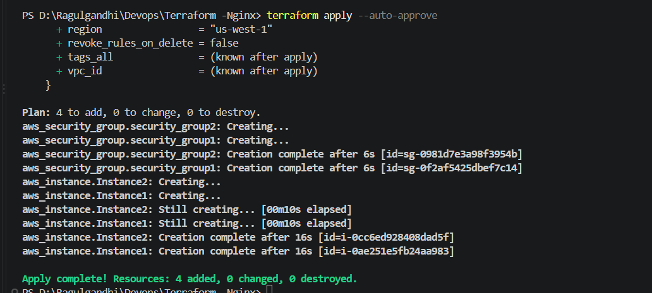
5.Connecting the instances.

US-East Region.
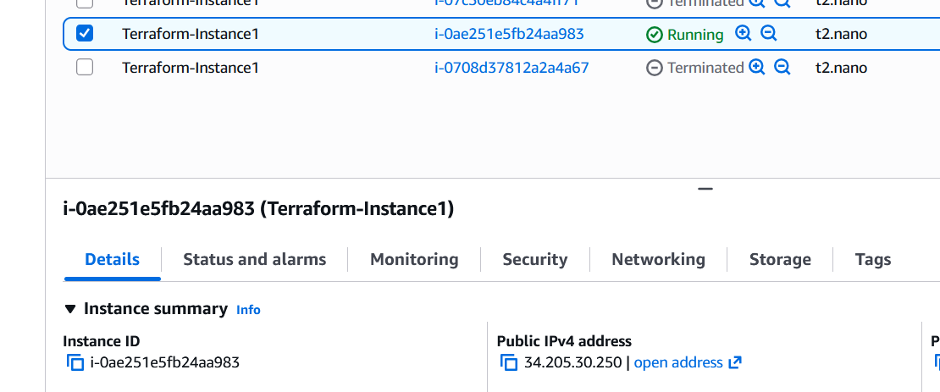
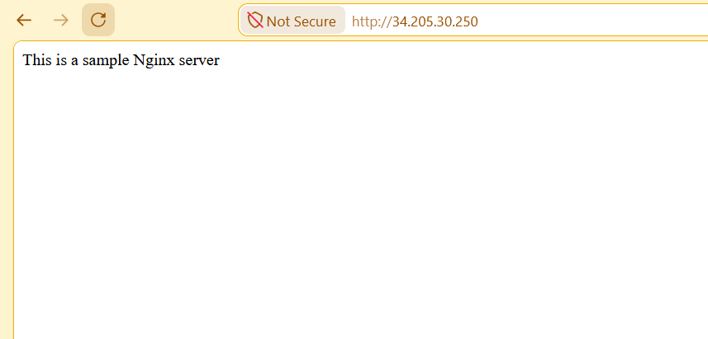
Us West Region:
